

**Shripriti**

Educational & IT Hub

Step towards your Success

**Project Report**

**On**

**Employee Management System**

**Submitted by**

**Chetan Kailas Banait**

**MCA II YEAR**

**SEM IV**

**Under the Guidance of**

**Prof. Pranjali Ulhe**

**Assistant Professor**

**Submitted to**

**Shripriti**

**Educational & IT Hub**

**Academic Year 2025-26**

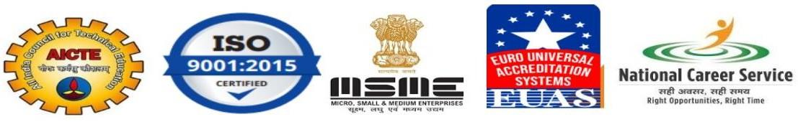

“**Employee Management System**”



**Shripriti**

Educational & IT Hub

Step towards your Success

## DECLARATION

We hereby declare that the Project work titled **“Employee Management System”** submitted to **Shripriti Educational & IT Hub** is a record of an original work done by us under the guidance of Prof. Pranjali Ulhe, Assistant Professor, School of Allied Sciences, Datta Meghe Institute of Higher Education & Research, Sawangi (Meghe) Wardha in the AY 2025-26 for a partial fulfillment of requirement.

This report has not been submitted to any other University or Institute for the award of any Internship

**MCA II Year Semester – IV : Chetan Kailas Banait**

**Place: Wardha, MH**

**Date: \_\_/\_\_/\_\_\_\_**



**Shripriti**

Educational & IT Hub

Step towards your Success

## ACKNOWLEDGEMENT

We would like to express our special thanks of gratitude’s to our Project guide Prof. Pranjali Ulhe, Faculty of Science and Technology, School of Allied Sciences, Datta Meghe Institute of Higher Education & Research, Sawangi (Meghe), Wardha for his/her able guidance and support in completing this report. We would like to extend my gratitude to and **Shripriti Educational & IT Hub ,** for providing me with all the facility that was required to complete this report successfully.

We also thank the management of **Shripriti Educational & IT Hub**  for providing me/us state of the art infrastructure and the opportunity to embark this Project. At last but not the least we are thankful to all my all teachers, staff who have been always helping and encouraging me/us throughout the period of this project.

**MCA II Year Semester – IV : Chetan Kailas Banait**

**Place: Wardha, MH**

**Table of Content**

|  |  |  |
| --- | --- | --- |
| **Chapter** | **Chapter Name** | **Page No** |
| 1 | Cover Page |  |
| 2 | Acknowledgment |  |
| 3 | Table of Contents |  |
| 4 | Introduction • Purpose of the Internship • Overview of Expectations • Technologies and Stack Covered |  |
| 5 | Weekly Breakdown • Week-by-week Summary • Challenges and Solutions |  |
| 6 | Mini Projects • Description and Features • Screenshots |  |
| 7 | Final Project:  • Project Overview • Objective and Motivation • Features Implemented • Frontend & Backend Technologies Used • Database Schema • APIs Created • Deployment Details |  |
| 8 | Learning Outcomes • Key Takeaways • Tools Learned • Real-world Experience |  |
| 9 | Conclusion • Internship Impact • Future Scope |  |
| 10 | Appendix • Code Snippets • GitHub Links • Extra Screenshots • References |  |

### Introduction

### ****Purpose of the Internship****

The purpose of this internship was to gain hands-on experience in web development by contributing to a real-world project. Through the development of an Employee Management System, I aimed to apply the knowledge acquired during the training phase, understand practical development workflows, and improve my problem-solving skills. This internship also helped bridge the gap between theoretical learning and its application in a professional environment.

### ****Overview of Expectations****

During the internship, I was expected to:

* Understand the requirements of a company-facing HR management tool.
* Learn and implement full-stack development using modern technologies.
* Design and manage a database to store and manipulate employee records securely.
* Develop user-friendly interfaces for both Admin and Employees.
* Test and debug the application thoroughly.
* Document the project including design, code structure, and user guide.
* Deploy the final product on a local or cloud server (if applicable).

#### Technologies and Stack Covered

During the project, the following technologies were used:

**Programming Language:** Java

**GUI Libraries:**

**AWT (Abstract Window Toolkit):** Used for basic components like Labels, TextFields, and Buttons.

**Swing:** Used to create a more flexible and modern-looking GUI with components like JFrame, JPanel, JTable, JButton, etc.

**Database:** File Handling (or optionally MySQL for advanced versions)

**IDE:** IntelliJ IDEA / NetBeans / Eclipse (depending on user preference)

**Key Concepts Practiced:**

* Event handling
* Exception handling
* MVC (Model-View-Controller) structure (if followed)
* CRUD operations using GUI components

This stack provided a good foundation in desktop GUI development using core Java, enhancing both programming logic and interface design skills.

**Weekly Breakdown**

**Week 1: Project Overview & Setup**

**Summary**: The first week focused on understanding the project requirements and setting up the development environment. I familiarized myself with the project structure and designed a basic framework for the Employee Management System. The system is intended to manage employee data, such as personal details, job information, and attendance.

**Challenges & Solutions**: The challenge was setting up the project’s database connection. The solution was to use JDBC for database integration and ensure that the necessary libraries were correctly linked.

**Week 2: Core Functionalities – Employee Registration**

**Summary**: Developed the employee registration functionality where users can add employee details such as name, ID, position, department, and contact information.

**Challenges & Solutions**: A challenge was validating the input data for proper format and handling missing data. I solved this by using conditional checks and Java exceptions to ensure data integrity and prompt users for correct information.

**Week 3: Employee Data Retrieval and Display**

**Summary**: Implemented functionality to retrieve and display employee data in a table format. Added search and filter options to make it easier for users to find specific employees.

**Challenges & Solutions**: The challenge was handling large datasets efficiently. To address this, I optimized SQL queries and added pagination for displaying employee data in manageable chunks.

**Week 4: Updating and Deleting Employee Records**

**Summary**: Worked on features for updating employee information (e.g., position changes or contact updates) and deleting employee records when required.

**Challenges & Solutions**: The challenge was ensuring data consistency and preventing accidental deletions. Implemented confirmation dialogues and used transaction management to ensure operations were performed correctly.

**Week 5: Employee Attendance Management**

**Summary**: Integrated attendance management features where employees can mark their attendance, and the system calculates work hours and attendance status.

**Challenges & Solutions**: A key challenge was managing attendance records efficiently and preventing duplicate entries. I solved this by implementing date checks and ensuring only one attendance entry per employee per day.

**Week 6: Reporting & Exporting Data**

**Summary**: Implemented the ability to generate employee reports, such as work hours, leaves taken, and performance. Added functionality to export reports as CSV files.

**Challenges & Solutions**: The challenge was formatting and exporting data correctly. I used Java's I/O streams and libraries such as OpenCSV to handle the data export efficiently.

**Week 7: Final Testing & Bug Fixing**

**Summary**: Conducted rigorous testing of all features and fixed any bugs or inconsistencies. Focused on ensuring all functionalities worked as intended and the system was stable.

**Challenges & Solutions**: Some minor bugs were found, particularly in edge cases like overlapping employee records. These were resolved by refining the validation logic and adding additional test cases to catch such issues.

**Week 8: Documentation & Final Presentation**

**Summary**: Prepared documentation for the Employee Management System, covering all functionalities, technical details, and instructions for usage. Presented the system to the team and gathered feedback.

**Challenges & Solutions**: Writing clear and concise documentation was a challenge. I overcame this by breaking down each module step-by-step and using diagrams to illustrate the system flow.

#### Mini Projects

#### ****1. Employee Management System****

**Description**:  
This mini project is a desktop-based application developed using Core Java and JDBC. It manages employee records such as personal details, job information, attendance, and salary. It provides a simple interface for HR departments or small organizations to maintain and update employee data.

**Key Features**:

**Add New Employee**: Input employee details and store them in the database.

**View All Employees**: Display all employee records in a tabular format.

**Update Employee Info**: Modify existing data such as role, department, or salary.

**Delete Employee**: Remove an employee's record permanently.

**Search Feature**: Search employee by name, ID, or department.

**Attendance Tracking**: Mark attendance and generate reports.

**Export to CSV**: Export employee and attendance data for record- keeping.

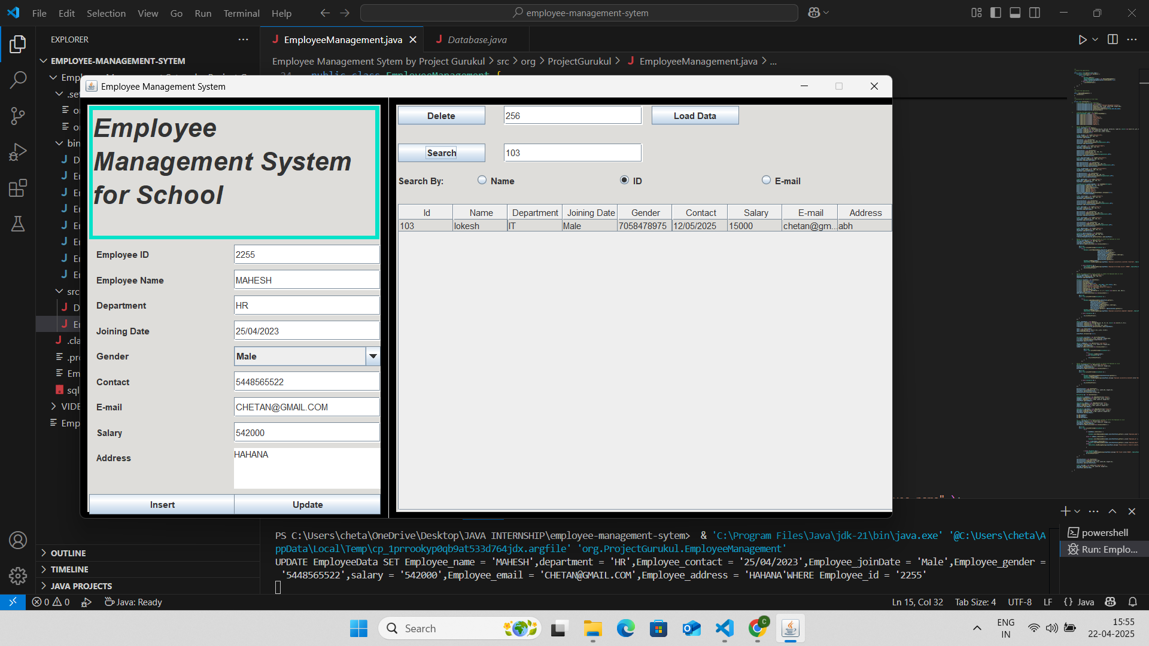

*Figure 1.: - Employee Management System Dashboard*

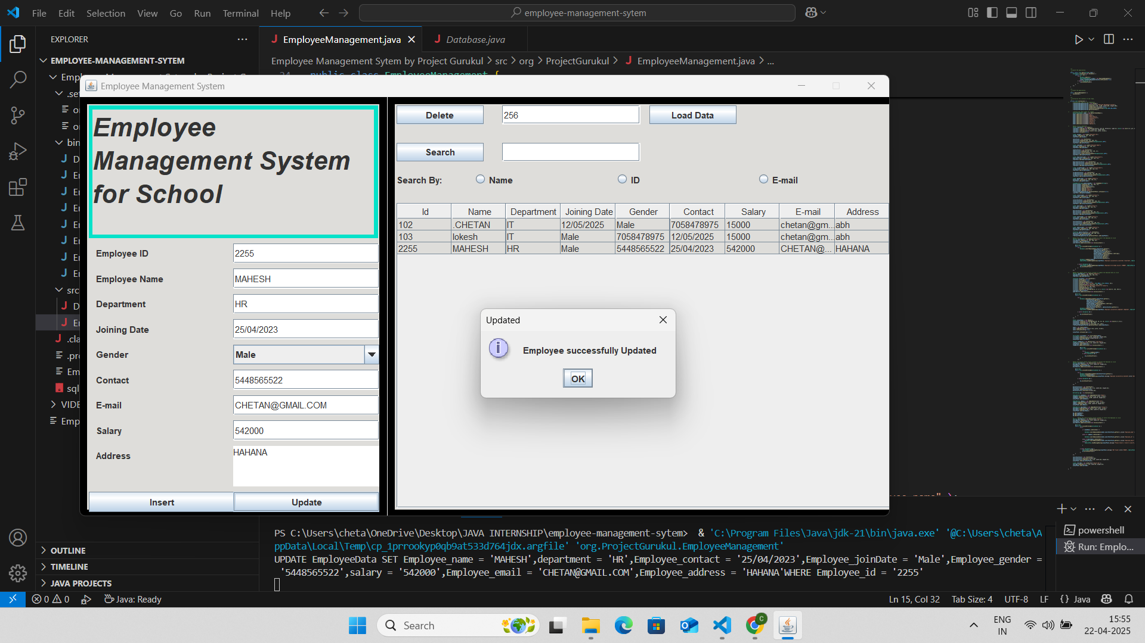

*Figure 2.: - Employee Added in System*

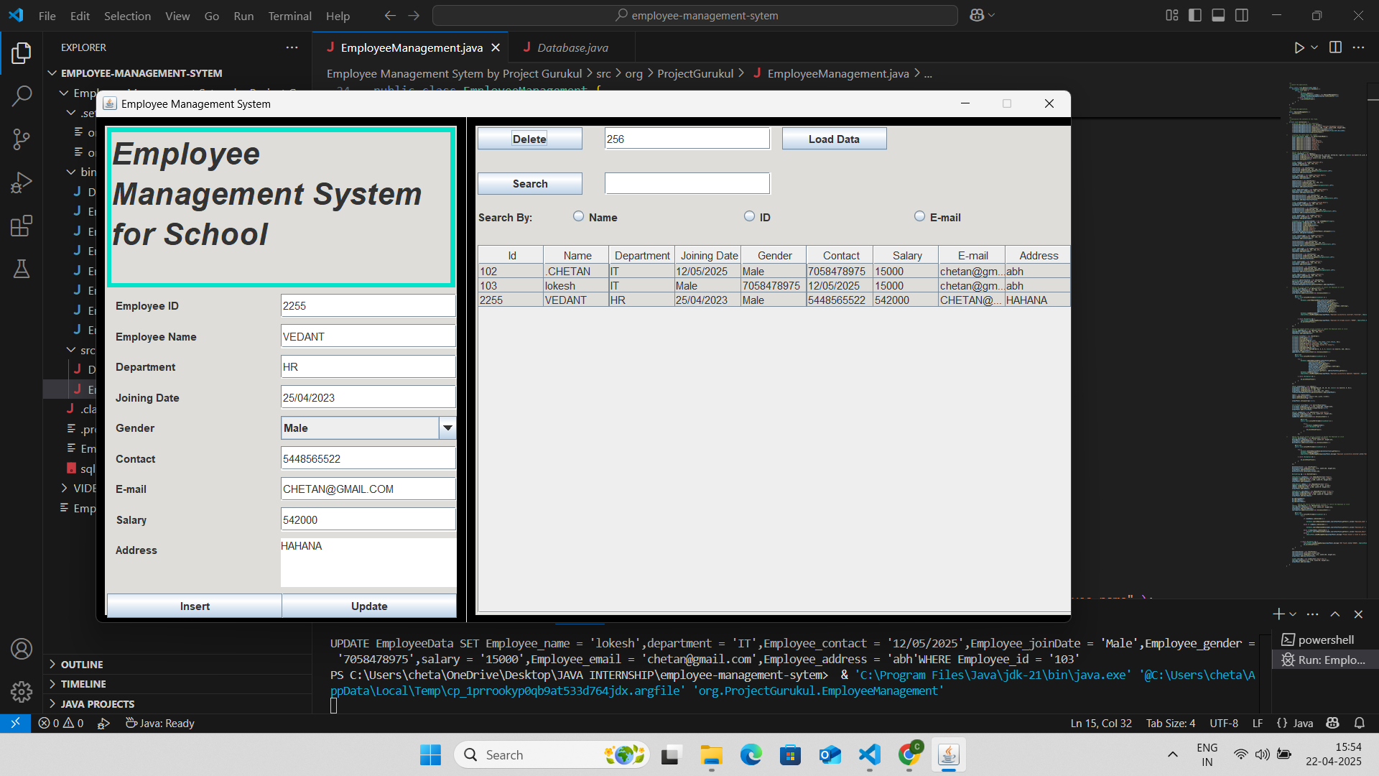

*Figure 3.: - Employee Management System Data*

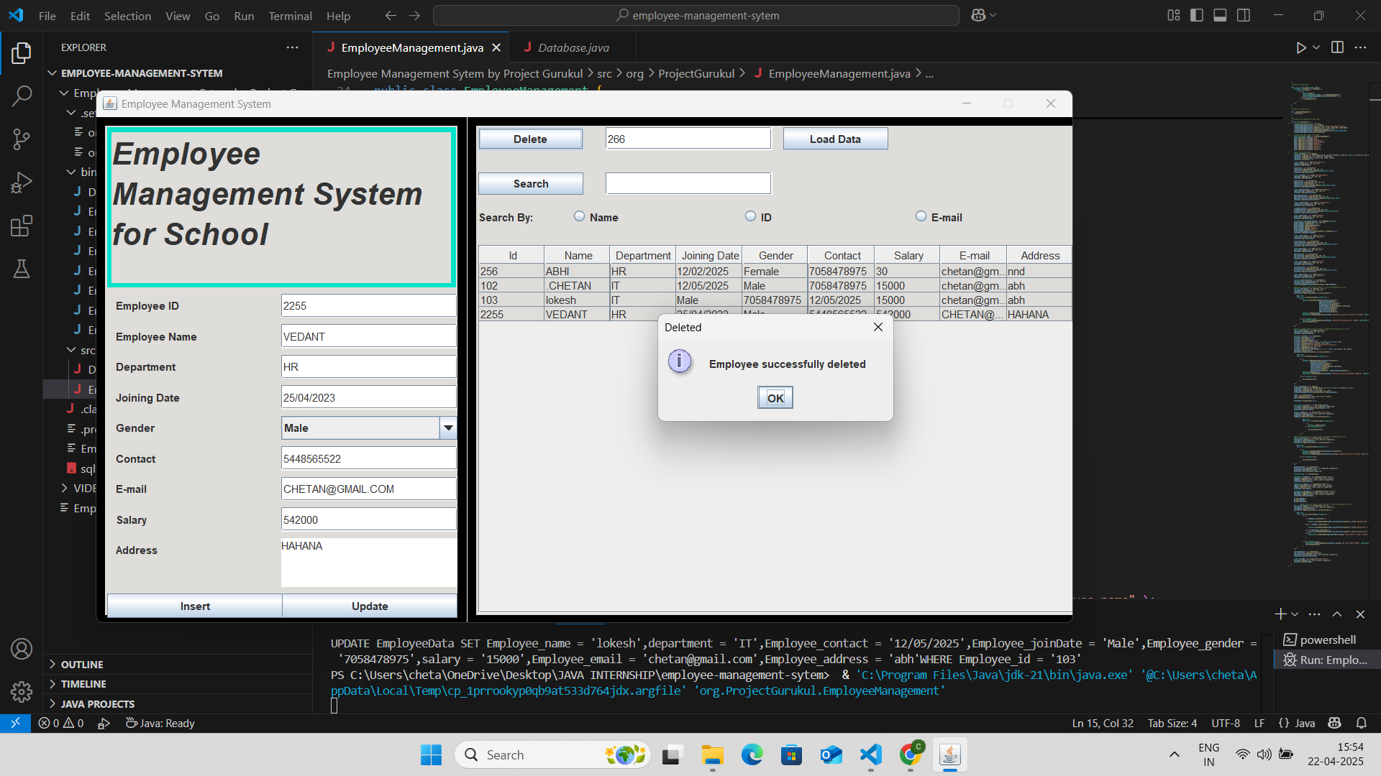

*Figure 4.: - Employee Delete in System*

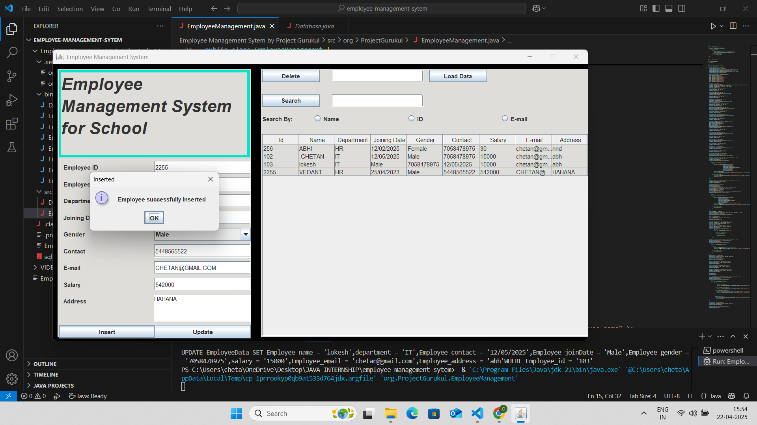

*Figure 5.: - Employee Inserted in System*

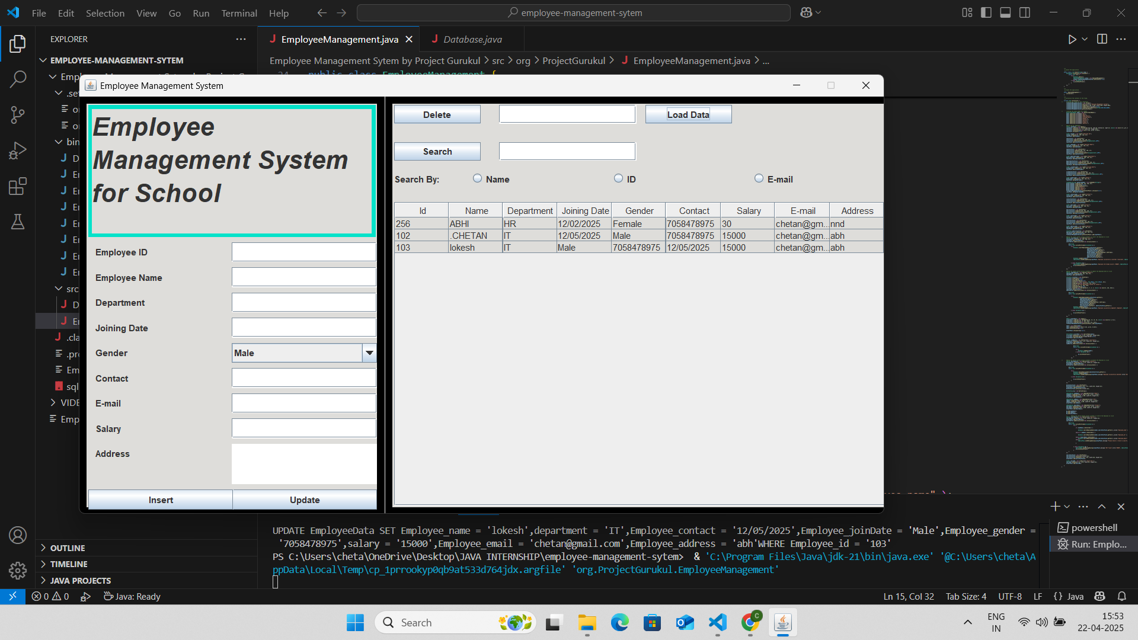

*Figure 6.: - Add New Employee in System*

Final Project:

### ****Project Overview****

The **Employee Management System (EMS)** is a desktop-based Java application that enables HR professionals or company administrators to manage employee records effectively. It covers essential functions such as employee registration, data retrieval, updating details, managing attendance, and exporting records. This system is designed to eliminate paperwork and manual handling by digitizing employee data and streamlining everyday HR tasks. Developed using Core Java and JDBC, this system interacts with a MySQL database to store and manage all employee-related information securely and efficiently.

### ****Objective and Motivation****

The primary objective of this project is to create an efficient system to manage employee data digitally, reducing errors and saving time. Manual methods are prone to mistakes and data loss; thus, automating these tasks improves accuracy and productivity. The motivation behind this project stemmed from observing how small businesses and institutions still rely on Excel sheets or handwritten records. This system empowers them to migrate to a digital platform without high costs or technical complexity.

### ****Features Implemented****

* Employee registration and unique ID generation
* View, update, and delete employee records
* Attendance marking with date/time
* Search by name, ID, or department
* Export employee and attendance data to CSV
* Admin login for security and access control
* User-friendly GUI for all operations

Each module is designed with validations and error handling for robust performance. User interaction is made simple through a menu-driven or form-based interface.

### ****Frontend & Backend Technologies Used****

**Frontend**: Java Swing (for GUI design)

**Backend**: Core Java (Object-Oriented Design), JDBC

**IDE Used**: NetBeans / Eclipse

**Development Tools**: Java SDK, MySQL Connector

### ****Database Schema****

The database consists of three main tables:

**employees** (emp\_id, name, department, designation, contact, email)

**attendance** (emp\_id, date, status)

**admin\_users** (username, password)

Each table is normalized to reduce redundancy. Primary keys and foreign key constraints maintain data integrity. The schema is designed to allow scalability for future modules like payroll or performance tracking.

### ****APIs Created****

While the system is primarily desktop-based, internal modular APIs (Java methods) were designed for:

* **addEmployee()**
* **getEmployeeById()**
* **updateEmployee()**
* **deleteEmployee()**

These internal APIs follow a structured model-view-controller pattern, allowing for reuse and easier maintenance. The separation of concerns keeps the application modular and testable.

### ****Deployment Details****

The application was packaged into an executable .jar file using NetBeans, making it platform-independent and easy to run on any machine with JDK installed. The MySQL database is hosted locally with configuration files for portability. The system can be deployed in a small office environment on LAN, with multiple users accessing it via shared database connections. Future versions can adopt cloud-based deployment with minor modifications, such as integrating REST APIs and remote MySQL hosting.

**Learning Outcomes**

### ****Key Takeaways****

Through the development of the Employee Management System, I gained a deep understanding of how to apply Core Java principles in real-world software development. Key takeaways include mastering object-oriented programming concepts such as inheritance, encapsulation, and abstraction. I also learned the importance of modular code design and how it simplifies debugging, testing, and future upgrades. This project enhanced my logical thinking, improved my problem-solving approach, and emphasized the value of planning before writing code. Understanding how different system components interact helped me appreciate the importance of designing scalable and maintainable systems.

### ****Tools Learned****

During this internship, I became proficient with a wide range of industry-relevant tools and technologies. I used:

**Core Java** for application logic

**Java Swing** for GUI design

**JDBC** for database connectivity

**MySQL** for backend data storage

**NetBeans/Eclipse** as IDEs for writing and debugging code

**Version Control (Git)** for tracking code changes

**OpenCSV** library for exporting data

These tools improved my coding efficiency and helped me adapt to professional development environments.

### ****Real-world Experience****

This project simulated a real-world software development cycle, from requirement gathering to deployment. I faced and overcame practical challenges such as debugging runtime errors, handling unexpected input, managing database connections, and ensuring data security. I learned how to communicate technical progress effectively, write clean and well-documented code, and test features thoroughly before delivery. The experience boosted my confidence and prepared me for teamwork and project handling in professional IT environments.

**Conclusion**

### ****Internship Impact****

This internship has had a significant impact on both my technical and professional development. Working on the Employee Management System project allowed me to bridge the gap between academic knowledge and industry application. It deepened my understanding of Core Java and introduced me to the structured flow of a real software development lifecycle. I learned to manage tasks independently, meet deadlines, and collaborate with mentors for feedback and improvement. Debugging issues, handling exceptions, managing databases, and creating user interfaces gave me hands-on experience in real-world problem-solving. Additionally, it boosted my confidence in using development tools like NetBeans, MySQL, and version control systems such as Git. The internship helped me understand the importance of documentation, modular coding, and testing practices, preparing me for job roles in software development and full-stack engineering.

### ****Future Scope****

The current version of the Employee Management System is a solid foundation, but it has immense potential for further enhancement. In the future, features such as payroll management, performance tracking, leave management, and integration with biometric systems for attendance can be added. A major upgrade could involve converting this desktop application into a web-based platform using technologies like Spring Boot and Angular. Additionally, deploying the system on a cloud platform would increase accessibility and scalability, making it ideal for larger organizations. RESTful APIs and role-based access control can also be implemented for improved functionality and security. This internship has laid the groundwork for all such possibilities and inspired me to keep learning and improving.

**Appendix**

### ****1. Code Snippets****

Below are some key code snippets that illustrate core functionalities of the Employee Management System:

**a. EmployeeManagment.java:**

java

CopyEdit

public void addEmployee(String name, String department, String contact) {

try {

Connection con = DriverManager.getConnection(DB\_URL, USER, PASS);

String query = "INSERT INTO employees (name, department, contact) VALUES (?, ?, ?)";

PreparedStatement pst = con.prepareStatement(query);

pst.setString(1, name);

pst.setString(2, department);

pst.setString(3, contact);

pst.executeUpdate();

JOptionPane.showMessageDialog(null, "Employee Added Successfully");

con.close();

} catch (SQLException e) {

e.printStackTrace();

}

}

**b. Attendance Marking:**

java

CopyEdit

public void markAttendance(String empId) {

try {

Connection con = DriverManager.getConnection(DB\_URL, USER, PASS);

String date = LocalDate.now().toString();

String query = "INSERT INTO attendance (emp\_id, date, status) VALUES (?, ?, 'Present')";

PreparedStatement pst = con.prepareStatement(query);

pst.setString(1, empId);

pst.setString(2, date);

pst.executeUpdate();

JOptionPane.showMessageDialog(null, "Attendance Marked");

con.close();

} catch (SQLException e) {

JOptionPane.showMessageDialog(null, "Error: " + e.getMessage());

}

}

### ****2. GitHub Links****

You can find the complete source code and project files on GitHub:

### ****3. References****

Java™ Platform, Standard Edition Documentation – Oracle  
[https://docs.oracle.com/javase/8/docs/](https://docs.oracle.com/javase/8/docs/" \t "_new)

JDBC API Guide – Oracle  
[https://docs.oracle.com/javase/8/docs/technotes/guides/jdbc/](https://docs.oracle.com/javase/8/docs/technotes/guides/jdbc/" \t "_new)

Java Swing Tutorial – Oracle  
[https://docs.oracle.com/javase/tutorial/uiswing/](https://docs.oracle.com/javase/tutorial/uiswing/" \t "_new)

OpenCSV Library – GitHub  
[https://github.com/opencsv/opencsv](https://github.com/opencsv/opencsv" \t "_new)

MySQL 8.0 Documentation – Oracle  
[https://dev.mysql.com/doc/refman/8.0/en/](https://dev.mysql.com/doc/refman/8.0/en/" \t "_new)